**Assignment-1**

**Name : Shiyam Saran**

**Reg no:122012012830**

**Sub code:**

**Sub name:**

**Topic : Different types of sensors**

**Types of Sensors in IoT**

**1. Temperature Sensor**

**Uses:**

* Used in smart homes for climate control.
* Industrial applications to monitor machine temperatures.
* Agriculture for soil and environmental monitoring.

**Working Principle:**

* Uses thermocouples, resistance temperature detectors (RTDs), or infrared sensors to measure temperature changes and convert them into electrical signals.

**Advantages:**

* High accuracy and fast response time.
* Low power consumption.
* Can be integrated into various IoT applications.

**Disadvantages:**

* Some sensors require calibration.
* Environmental factors like dust and humidity can affect accuracy.

Diagram:

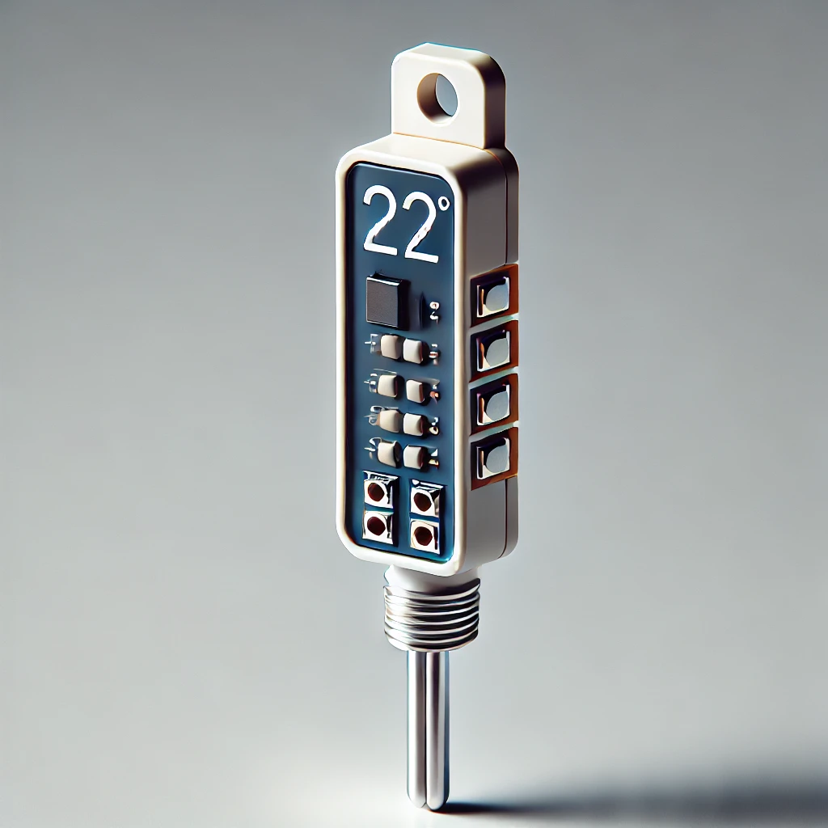

**2. Humidity Sensor**

**Uses:**

* HVAC systems for air quality monitoring.
* Agriculture to monitor soil moisture levels.
* Healthcare for patient monitoring.

**Working Principle:**

* Measures changes in capacitance or resistance due to moisture content in the air and converts it into readable data.

**Advantages:**

* Provides real-time data for automation.
* Compact and cost-effective.
* Works in various environmental conditions.

**Disadvantages:**

* Can degrade over time.
* Requires periodic calibration.

Diagram:



**3. Proximity Sensor**

**Uses:**

* Used in automotive applications for collision detection.
* Industrial automation for object detection.
* Smartphones for touchless interactions.

**Working Principle:**

* Detects objects without physical contact using infrared, ultrasonic, or electromagnetic waves.

**Advantages:**

* Highly reliable and durable.
* Works well in harsh environments.
* No mechanical wear and tear.

**Disadvantages:**

* Limited range.
* Can be affected by environmental factors like temperature and humidity.

Diagram:

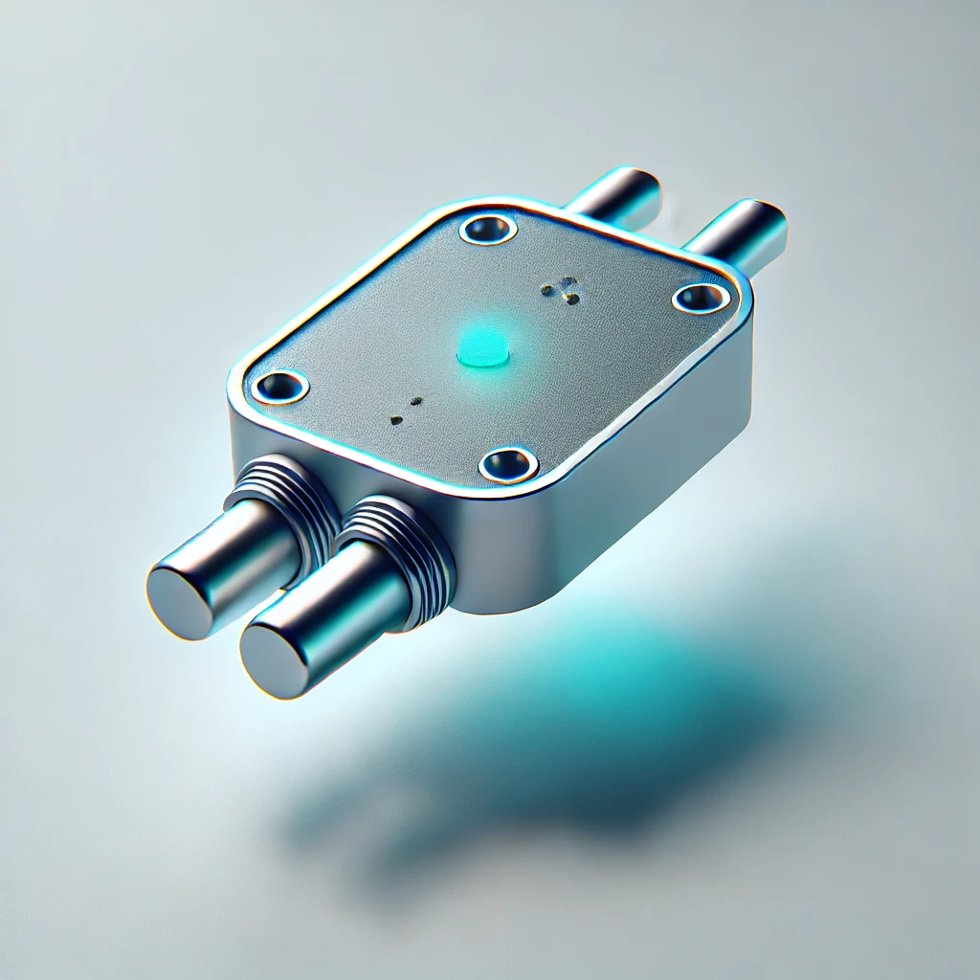

**4. Gas Sensor**

**Uses:**

* Air quality monitoring in smart cities.
* Industrial safety for detecting hazardous gases.
* Healthcare for breath analysis.

**Working Principle:**

* Uses electrochemical, infrared, or semiconductor-based detection to measure gas concentration.

**Advantages:**

* High sensitivity and fast response.
* Can detect multiple gases.
* Essential for safety applications.

**Disadvantages:**

* Requires regular calibration.
* Sensitive to temperature and humidity variations.

Diagram:

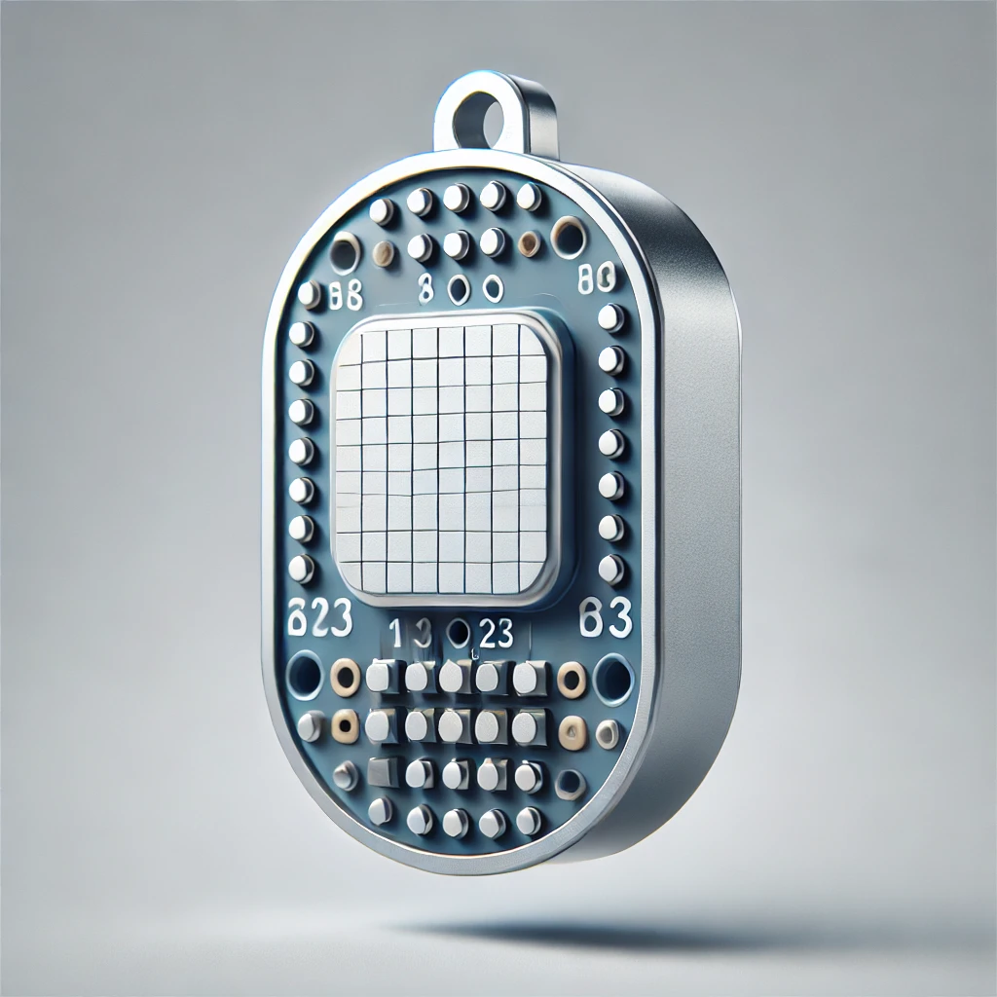

**5. Light Sensor**

**Uses:**

* Smart lighting systems in homes and cities.
* Mobile devices for screen brightness adjustment.
* Security systems for motion detection.

**Working Principle:**

* Converts light intensity into an electrical signal using photodiodes or photoresistors.

**Advantages:**

* Energy-efficient.
* Compact and easy to integrate into IoT systems.
* Provides automatic lighting control.

**Disadvantages:**

* Can be affected by dust and environmental changes.
* Limited range in detecting light variations.

Diagram:

